2022
MINNESOTA
ELECTION JUDGE TRAINING WORKBOOK

Office of the Minnesota Secretary of State
180 State Office Building
100 Rev. Dr. Martin Luther King Jr. Blvd.
St. Paul, MN 55155
Phone: (651) 215-1440
Toll Free: 1-877-600-8683
Minnesota Relay Service: 1-800-627-3529
Email: elections.dept@state.mn.us
Website: www.sos.state.mn.us

Contents
Precinct Finder Exercise 7
Precinct Finder - Question # 1 7
Precinct Finder - Question # 2 7
Precinct Finder - Question # 3 7
Precinct Finder - Question # 4 7
Precinct Finder - Question # 5 7
Election Day Registration Exercise 9
EDR - Question # 1 9
EDR - Question # 2 9
EDR - Question # 3 9
EDR - Question # 4 9
EDR - Question # 5 10
EDR - Question # 6 10
EDR - Question # 7 11
EDR - Question # 8 11
EDR - Question # 9 12
Summary Statement Exercise 13
Summary Statement Exercise Materials 14
Summary Statement to Complete 15
Security Practices Quiz 16
Security Practices - Question # 1 16
Security Practices - Question # 2 16
Security Practices - Question # 3 16
Security Practices - Question # 4 16
General Knowledge Quiz 17
General Knowledge - Question # 1 17
General Knowledge - Question # 2 17
General Knowledge - Question # 3 17
General Knowledge - Question # 4 17
General Knowledge - Question # 5 17
General Knowledge - Question # 6 18
General Knowledge - Question # 7 18
General Knowledge - Question # 8 18
General Knowledge - Question # 9 18
General Knowledge - Question # 10 18
General Knowledge - Question # 11 19
General Knowledge - Question # 12 19
General Knowledge - Question # 13 19
General Knowledge - Question # 14 19
Roster Quiz 20
Roster - Question # 1 20
Roster - Question # 2 20
Roster - Question # 3 20
Roster - Question # 4 20
Roster - Question # 5 21
Roster - Question # 6 21
Roster - Question # 7 21
Registration Judge Quiz 22
Registration - Question # 1 22
Registration - Question # 2 22
Registration - Question # 3 22
Registration - Question # 4 22
Registration - Question # 5 22
Registration - Question # 6 22
Registration - Question # 7 23
Registration - Question # 8 23
Registration - Question # 9 23
Registration - Question # 10 23
Registration - Question # 11 23
Demonstration & Ballot Judge Quiz 24
Ballots - Question # 1 24
Ballots - Question # 2 24
Ballots - Question # 3 24
Ballots - Question # 4 24
Ballots - Question # 5 25
Ballots - Question # 6 25
Ballots - Question # 7 25
Ballot Counter Judge Quiz 26
Ballot Counter - Question # 1 26
Ballot Counter - Question # 2 26
Ballot Counter - Question # 3 26
Ballot Counter - Question # 4 26
Ballot Counter - Question # 5 26
Ballot Counter - Question # 6 26
Voter Challenger Quiz 27
Challengers - Question # 1 27
Challengers - Question # 2 27
Challengers - Question # 3 27
Challengers - Question # 4 27
Challengers - Question # 5 27
Challengers - Question # 6 27
Polling Place Conduct Quiz 28
Conduct - Question # 1 28
Conduct - Question # 2 28
Conduct - Question # 3 28
Conduct - Question # 4 28
Conduct - Question # 5 28
Conduct - Question # 6 29
Conduct - Question # 7 29
Answer Key 30
Precinct Finder Exercise Answers 30
Election Day Registration Exercise Answers 30
Summary Statement Exercise Answers 30
Security Practices Quiz Answers 31
General Knowledge Quiz Answers 31
Roster Quiz Answers 31
Registration Judge Quiz Answers 32
Demonstration & Ballot Judge Quiz Answers 32
Ballot Counter Judge Quiz Answers 32
Voter Challenges Quiz Answers 33
Polling Place Conduct Quiz 33

Precinct Finder Exercise
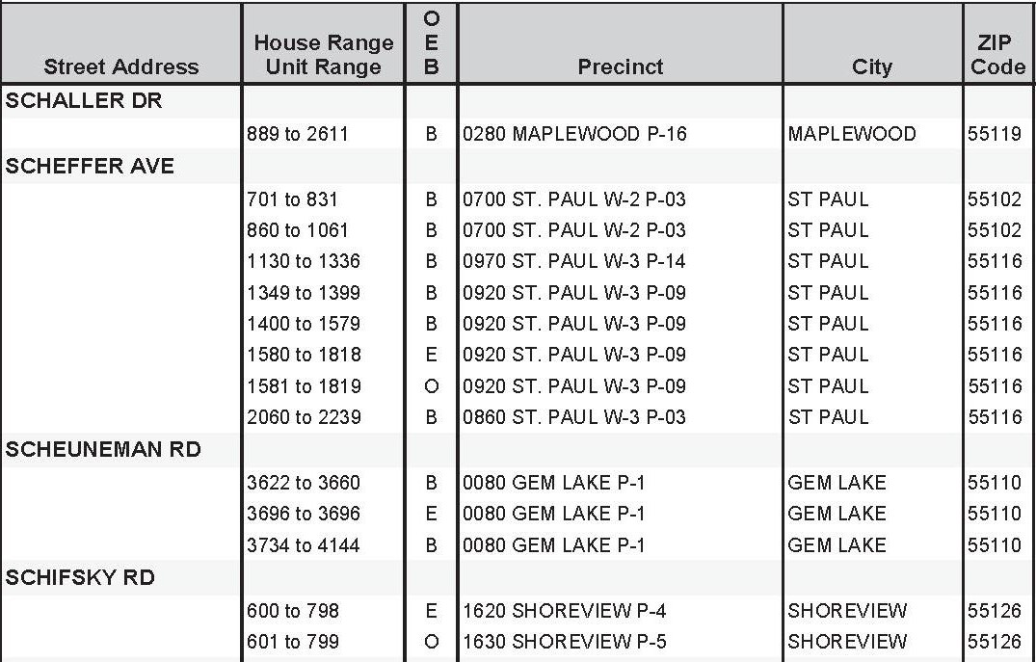
Figure 1: Portion of a Precinct Finder to use for Exercise
Use this sample precinct finder to answer the questions in this section.

Precinct Finder - Question # 1
The precinct finder should be used to verify the address of: Circle all that apply
- Every voter who registers to vote on Election Day.
- Every voter who is not sure if they are in the correct polling place.
- Every voter.
- Every voter that has a challenge.

Precinct Finder - Question # 2
Sam goes to the Shoreview P-6 polling place with a residential address of 604 Schifsky Road. Is this the precinct? ________
If not, what is Sam’s correct precinct? _________

Precinct Finder - Question # 3
At Saint Paul W-3 P-3 polling place, Kerry would like to register and vote with a residential address of 900 Scheffer Avenue. Is Kerry trying to register and vote in the correct precinct? _______
If not, what is her correct precinct? _________

Precinct Finder - Question # 4
George lives at 3640 Scheuneman Road and goes to vote at Gem Lake P-1 polling place. Is this correct? ________

Precinct Finder - Question # 5
If you cannot find an address on the Precinct Finder, what should you do?
Response: _________________________________________________________________________

Election Day Registration Exercise

EDR - Question # 1
Voter A presents a photo ID and a current bank statement. The bank statement is on their smartphone’s screen and not a paper copy. Can Voter A register? Circle the correct answer
- No, the voter must provide a paper copy to attach to the registration application.
- It depends on the type of smartphone.
- Yes, the bill can be displayed on any electronic device.

EDR - Question # 2
Voter B’s Minnesota driver’s license has their old address. They do not receive any bills in their name. What are Voter B’s options? Circle all that apply
- A roommate can vouch for them, if their roommate is already registered or registered previously on Election Day using another method other than vouching.
- They can update their driver’s license and bring in a receipt for the new license.
- They can use the “welcome to the city” letter they received from their city government.
- They should go vote at the precinct that is correct for their old address.

EDR - Question # 3
Voter C lives in a house with 9 college roommates. All need to register. The lease and house utility bills are in Voter C’s name. What options do their roommates have? Circle all that apply
- Voter C registers and then vouches for 8 of their roommates.
- Voter C’s roommates can provide another bill, such as cell phone, with their current address, along with a photo ID.
- They cannot register. College students must vote in their home precincts (where their parents live).
- Voter C registers and then vouches for all their roommates.

EDR - Question # 4
Voter D moved to the apartment directly across the hall from their old apartment. They are already on the registered roster showing their old apartment number. What documentation does Voter D need to register to vote? Circle the best answer
- A utility bill that lists their new apartment number.
- Another resident in the building (or precinct) that could vouch for them.
- Nothing as “previous registration in the precinct” is sufficient.
- They could update their driver’s license to reflect their apartment change.

EDR - Question # 5
Derek Sample would like to register to vote at the address of 3300 Century Ave N, White Bear Lake, MN 55110 with the following documents for an election on November 8, 2022. Can Derek register with the following documents? Circle the correct answer
- Yes
- No
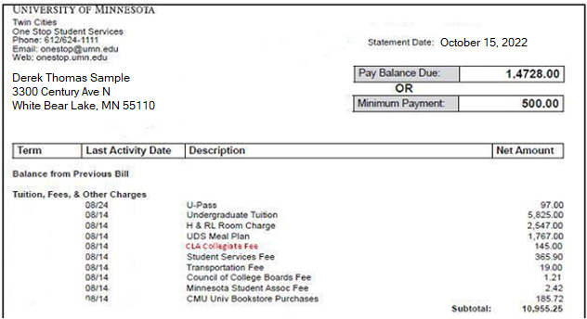
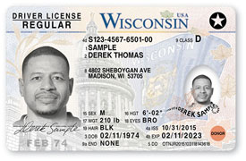
Figure 2: Samples of Student Fee Statement & Out of State Driver's License for Exercise

EDR - Question # 6
If Voter E presented you with these documents, show how would you complete the “Election Judge Official Use Only” section at the bottom of the application:
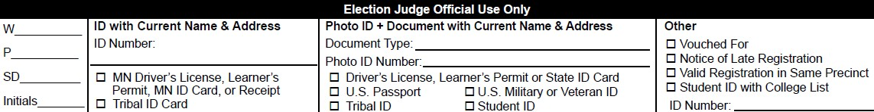
Figure 3: Sample of "Election Judge Official Use Only" Section of EDR VRA

EDR - Question # 7
Voter F moved to Minnesota 31 days prior to Election Day, but only has the driver’s license receipt that was given to them at the DMV when they applied for a Minnesota license. They want to know what else they need to register, since the receipt does not have their photo on it. What advice can you give as a registration judge? Circle the correct answer
- Voter F can vote a provisional ballot, which will be accepted once their driver’s license arrives in the mail.
- Voter F needs to bring a current utility bill with them to confirm their residency.
- Voter F is still eligible to vote in their prior state of residence and should have voted absentee from there.
- Voter F can register using the receipt alone.

EDR - Question # 8
Can Avery register and vote on the November 8th, 2022, election date at his current address (345 7th St W., St Paul, MN 55104) with the following documents? If not, list some of the documents Avery could use to register.
___________________________________________________________________________
___________________________________________________________________________
___________________________________________________________________________
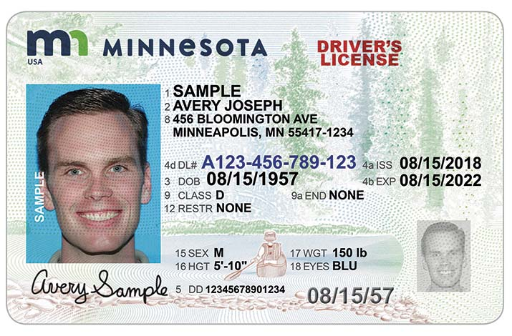
Figure 4: Sample of MN Driver's License
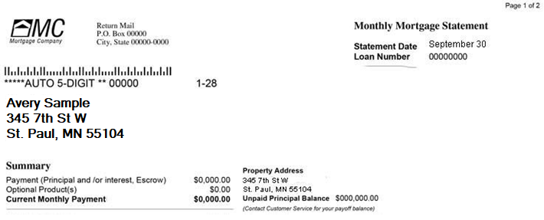
Figure 5: Sample Mortgage Statement

EDR - Question # 9
Jeff hands you the following document. What else will Jeff need to register? Circle the correct answer
- A valid photo ID.
- A valid photo ID and a current bill.
- An old photo and a current bill.
- Jeff does not need anything additional to register.
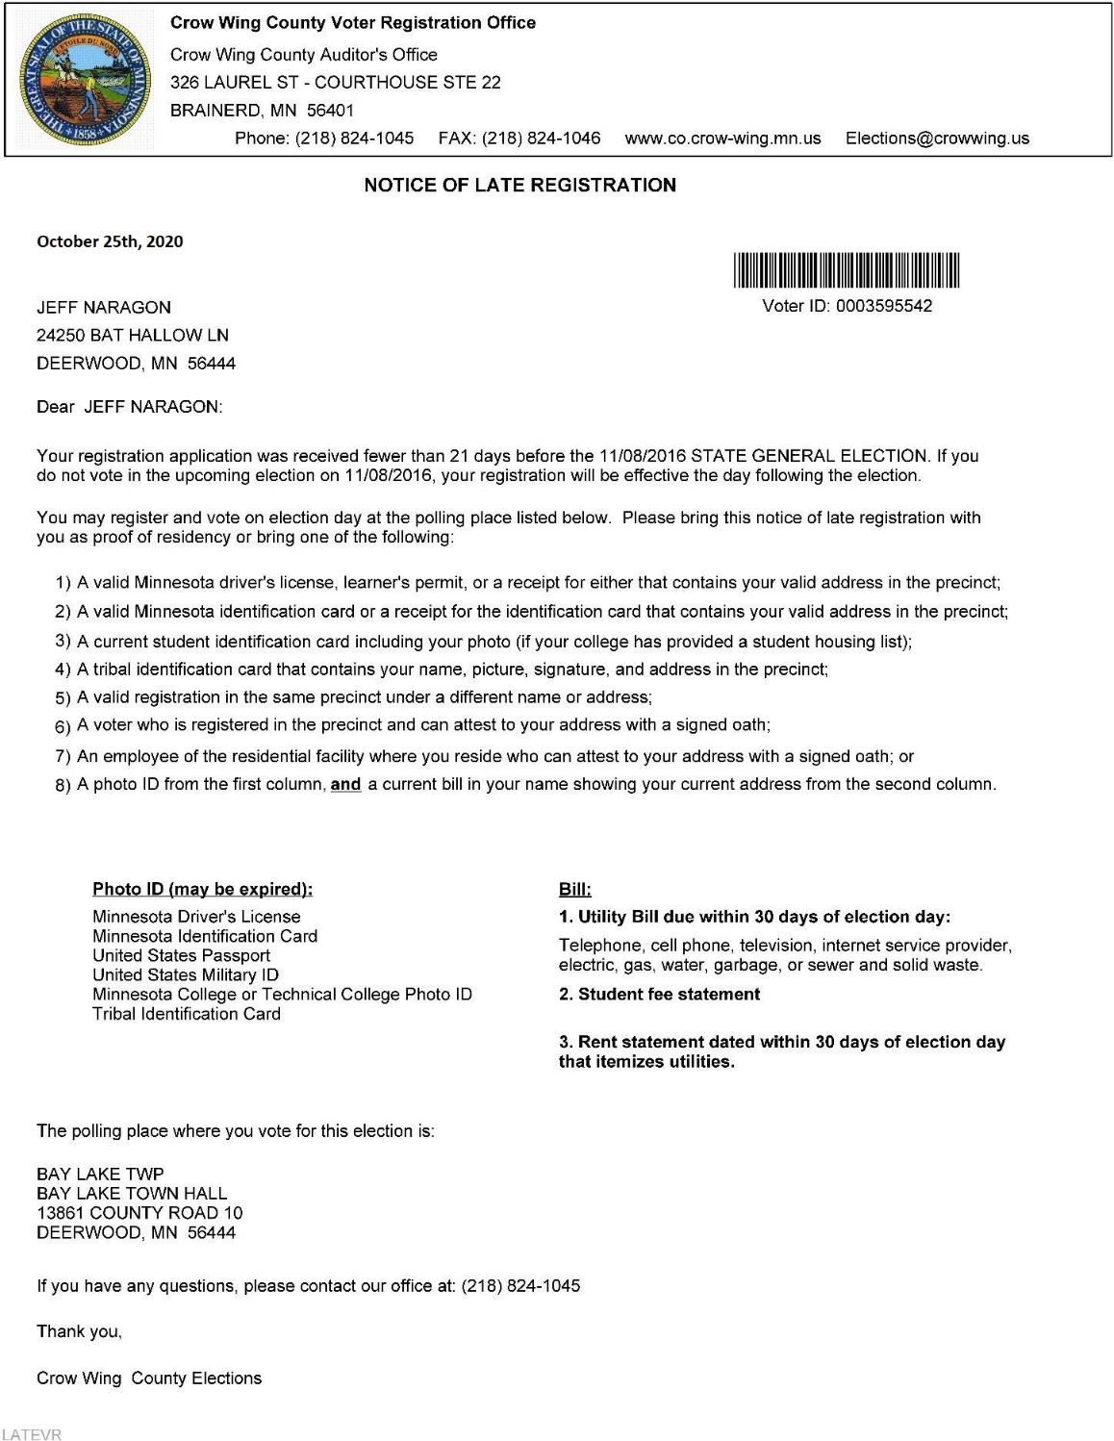
Figure 6: Sample of Notice of Late Registration

Summary Statement Exercise
Practice compiling basic election night statistics using the instructions below and the supplemental documents on page 13. List your answers on the sample summary statement on page 14.
Instructions for Completing the Summary Statement
The first step in gathering statistics is to make sure that the number of ballots the machine counted matches the number of people who voted. The results tape (see page 13) will list the number of ballots counted — compare that to the number of signatures on both voter rosters (see bottom of this page & page 13). Do not count lines marked ‘AB’ as signatures.
- Number of ballots counted: ___________
- Number of voter receipts or signatures on all rosters: _____________
- If the numbers do not match, examine the incident log, and provide an explanation of what happened:
___________________________________________________________________
___________________________________________________________________
___________________________________________________________________
Now, provide a new tally of ballots counted and voted receipts to ensure they match:
- Number of ballots counted: ____________________
- Number of voter receipts or signatures on all rosters: ____________________
Finally, document the remaining statistics onto the Summary Statement on page 14.

Information for Summary Statement Exercise:
- There is an EDR roster page with 3 signatures of three new voters on election day.
- There is an incident log notation that says:
Opened shrink wrapped ballot packet and only 18 ballots were present not 20 (-2 ballots)
- There is another incident log notation that says:
Danny Smith signed the roster and then afterward was informed he is in the wrong polling place. Danny did not receive a ballot.

Summary Statement Exercise Materials
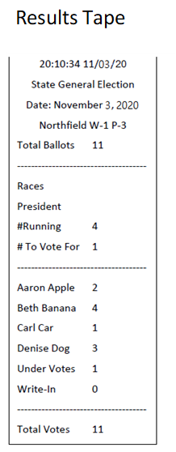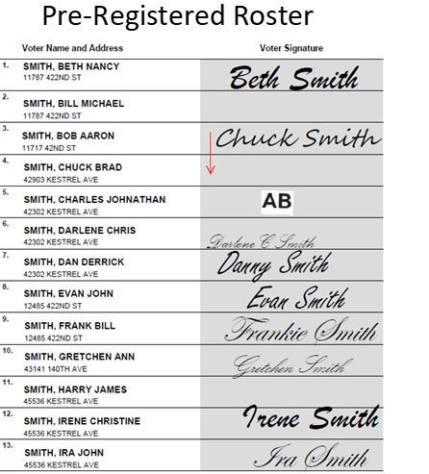

Summary Statement to Complete
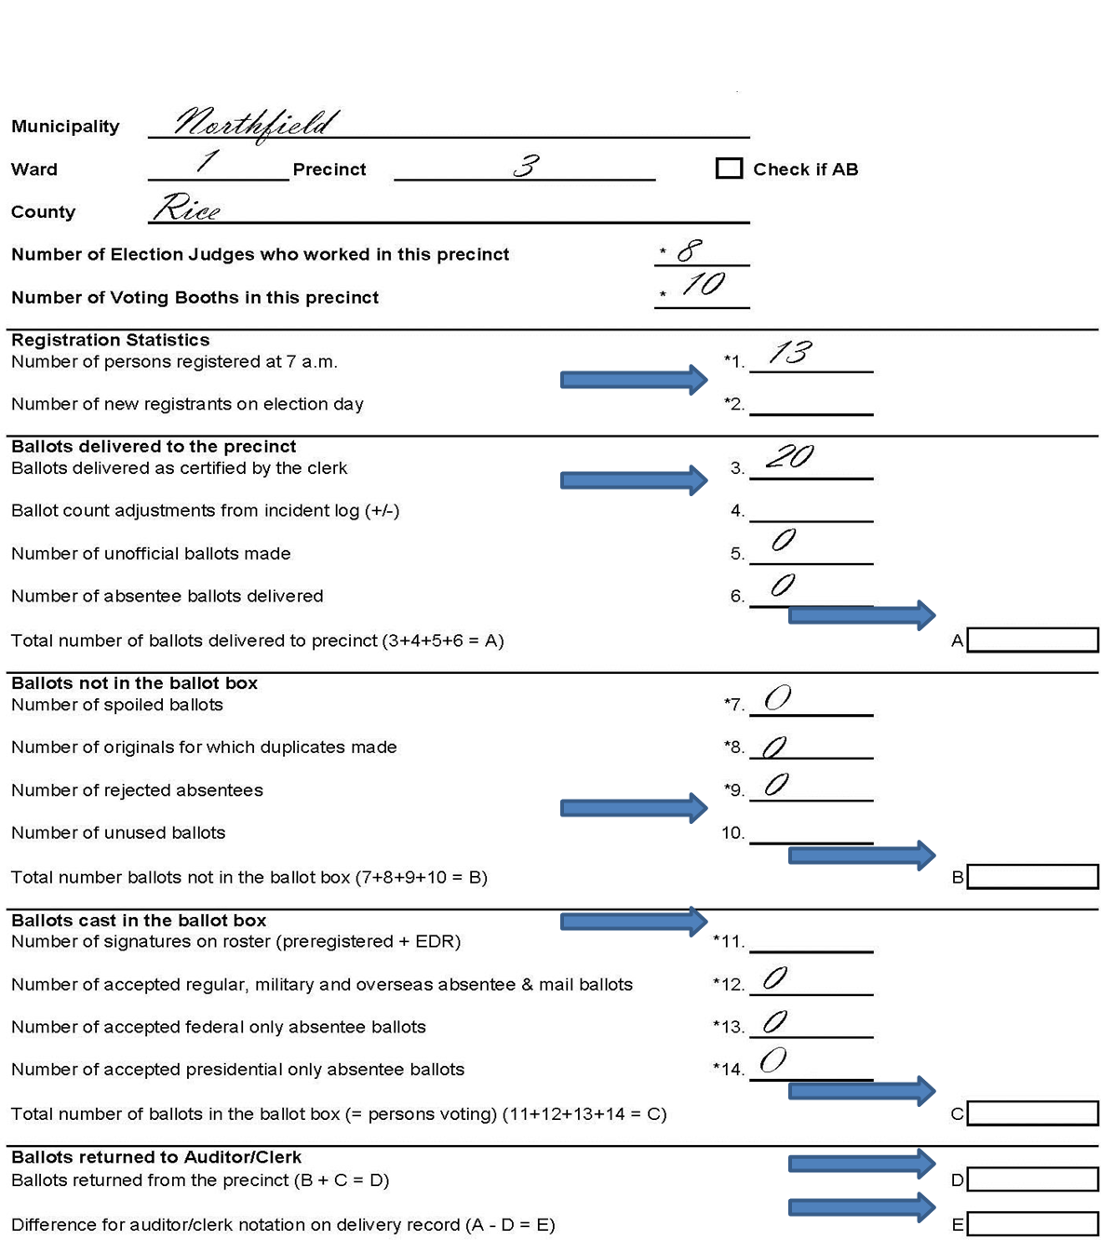
Figure 7: Sample Summary Statement for Exercise

Security Practices Quiz

Security Practices - Question # 1
Before the polls open, election judges were setting up the ballot counter in their polling place. They noticed that the wire seal on the memory card/stick port was broken. What should they do next? Circle the best answer
- Yell out, “The seal is broken, the seal is broken,” and pound their fists on the ballot counter.
- Stop setting up the ballot counter and notify the head judge that the seal is broken. Wait for further instructions
- Just throw away the broken seal and continue with setting up the ballot counter.

Security Practices - Question # 2
The election judges setting up the ballot marker (before the polls open) have notified the head judge that there is a problem with the seal. The sticker seal that covers the memory card/stick port has ripped. What should the head judge do next? Circle the best answer
- Notify the main election clerk/official of the ripped seal and follow their directions for next steps.
- Immediately lock all doors to the building and tell voters that the polling place is closed until further notice.
- Place a piece of tape on the door and go back to completing other opening tasks.

Security Practices - Question # 3
Why is it important to make sure that candidate names/rotations/question numbers on “zeros” tape/report matches the ballots sent to that polling place for Election Day? Circle the best answer
- It confirms that the correct ballots are in the poll place before voting begins.
- It provides some reassurance that tampering of the memory card/stick has not occurred.
- It confirms that the tabulator is working before the polls open.
- All of the above

Security Practices - Question # 4
A group of protesters had entered the gymnasium where voting was taking place. The head election judge, under the direction of the main election official, called in police to remove the protesters. After removal of the protesters, the head judge asked the officers to stay because they were worried about “more protesters showing up later.” Are officers allowed to remain in a polling place after peace is restored?
- Yes
- No

General Knowledge Quiz

General Knowledge - Question # 1
Who issues ballots to the voters? Circle the correct answer
- Registration judges.
- The judge who receives voter receipts.
- The ballot counter judge.
- The head judge.

General Knowledge - Question # 2
What events must be noted in the incident log when they occur? Circle all that apply
- Discrepancies in ballot counts when opening ballot packets.
- Unusual events or incidents.
- The names of vouchers.
- The names of people who accompany voters as assistants.

General Knowledge - Question # 3
What is a voter receipt? Circle the correct answer
- The receipt a voter gets when they register.
- The receipt a voter gets after they vote.
- The receipt a voter gets if they use curbside voting.
- The receipt a voter gets after signing the paper pre-registered or Election Day registration roster.
- Both A & D

General Knowledge - Question # 4
What is the minimum number of election judges in a polling place who must represent different major political parties? Circle the correct answer
- 4
- 2
- There is no minimum.

General Knowledge - Question # 5
In your own words, what is curbside voting?
_______________________________________________________
_______________________________________________________

General Knowledge - Question # 6
Who can mark their ballot using the ballot-marking machine? Circle the best answer
- Voters who are blind.
- Voters with any form of disability.
- Any voter.

General Knowledge - Question # 7
You are setting up the ballot-marking machine--what factors do you use to decide where to place it in the polling place? Circle the best answer
- Proximity to electrical outlet.
- Privacy afforded to the voter.
- Obstacles in the path of voters approaching it.
- All of the above.

General Knowledge - Question # 8
Which of the following are required by law to be in every polling place? Circle the correct answer
- Chairs for voters who need to sit on while waiting to register or vote.
- A ballot counter machine.
- A list posted on the wall of emergency phone numbers.

General Knowledge - Question # 9
Political discussions between election judges are okay if not within earshot of voters? Circle the correct answer
- True
- False

General Knowledge - Question # 10
If there is a line of voters waiting to vote at 8 p.m., the election judges should: Circle the correct answer
- Stop issuing ballots immediately.
- Determine who the last person in line is at 8 p.m.
- Announce that the polling place is closed at 8 p.m. and all in line are allowed to vote.
- Both B & C.

General Knowledge - Question # 11
What should be in the ballot box when the polling place is declared open? Circle the correct answer
- Blank ballots.
- Election supplies.
- Nothing.

General Knowledge - Question # 12
How close can a voter come to the ballot box if they are not about to cast a ballot? Circle the correct answer
- There is no rule.
- They must stay at least 15 feet away.
- They must stay at least 6 feet away.

General Knowledge - Question # 13
What is a summary statement? Circle the correct answer
- A document completed at the end of the day of the precinct’s voting, registration, and ballot statistics.
- A document that lists any problems or unusual events during the day.
- The document an authorized challenger presents when making a challenge.
- A document provided at the beginning of the day summarizing how many ballots were delivered.

General Knowledge - Question # 14
A voter asks an election judge what effect a ballot question will have if it passes. What should the election judge say? Circle the correct answer
- Provide basic, fair, and impartial thoughts about the ballot question’s effects.
- Tell the voter you cannot provide any information.
- Give your opinion, but clearly state that it is an opinion and there is another side to your viewpoint.

Roster Quiz

Roster - Question # 1
A voter signs the paper roster, and then mentions they have recently married and changed their name. What should the roster judge do? Circle the correct answer
- Make the voter sign their new name on the roster.
- Ask the voter if they had a dessert at their wedding reception?
- Ask the voter to update their registration sometime in the coming weeks.
- Direct the voter to the registration table to update their registration. Place a line through the signature on the paper roster. Add the time and the initials of the election judge on the voter’s signature line.

Roster - Question # 2
What is a roster notation? Give an example.
______________________________________________________________________
______________________________________________________________________

Roster - Question # 3
A voter is about to sign the roster and the notation “Challenge—Postal Return” is next to their name. When administering the roster challenge process, what question is the most appropriate? Circle the correct answer
- What is your current address?
- What country were you born?
- What is your full legal name?

Roster - Question # 4
A voter sees that someone else has already signed next to their name. Upon inspection, you find that the voter directly above signed on the wrong line on the paper roster. How do you handle this situation? Circle the correct answer
- Call the voter who signed the wrong line and ask them to come back to the polls.
- Ask the head judge for guidance.
- Tell the voter that, unfortunately, they cannot vote.

Roster - Question # 5
What does “A.B.” mean on the signature line of a paper roster or the screen of an electronic roster? Circle the correct answer
- They are the initials of the election judge who approved the roster.
- The voter has applied for an absentee ballot, but it was not received or returned.
- The person voted by absentee ballot and cannot vote at the polling place.

Roster - Question # 6
Name two tips for finding names on a paper roster:
___________________________________________________________________
___________________________________________________________________

Roster - Question # 7
Under what circumstances must a voter who appears on the roster re-register? Circle the best answer
- Change of name.
- Change of address in the precinct.
- Moved from one apartment to another in the same building.
- All of the above.

Registration Judge Quiz

Registration - Question # 1
What is one of the first steps when registering a voter? Circle the correct answer
- Confirm that the voter is at the correct precinct, using the precinct finder.
- Give the voter a copy of the Minnesota voter’s bill of rights.
- Ask the voter to show their photo ID.

Registration - Question # 2
A family moved from Saint Paul to Bemidji five days before the election. Can they vote in Bemidji? Circle the correct answer
- No, because they have not resided in the precinct for more than 20 days.
- Yes. A voter must live in Minnesota for 20 days, not in a specific precinct for 20 days.
- No. They must vote from their previous address.

Registration - Question # 3
A voter forgets their ID. Can they leave and come back with it later? Circle the correct answer
- No. If persons leave without voting, they cannot return later to vote.
- Yes. Voters can leave and come back anytime during the voting hours to register and vote.

Registration - Question # 4
Can a voter who registers on Election Day vouch for another voter? Circle the correct answer
- No. Only pre-registered voters can vouch for others. Their name must already on the roster before vouching for anyone else.
- Yes. People who register, using any type of registration process, on Election Day can vouch for others.
- Yes. If the voter did not register by being “vouched for.”

Registration - Question # 5
A residential facility staff person wants to vouch for 12 residents. Can they? Circle the correct answer
- No. They can only vouch for up to 8 of the residents.
- No. Staff people cannot vouch for residents, only another registered voter can vouch for them.
- Yes, they can vouch for all 12—unlike a registered voter who can vouch for a maximum of eight, residential facility staff can vouch for any eligible voters who reside at the facility.

Registration - Question # 6
Who cannot be a voucher? Circle the correct answer
- A candidate at the election.
- An election judge who is a registered voter in the precinct.
- A person who registers the same day with a voucher.

Registration - Question # 7
A voter comes to register who has had a felony conviction. What should you tell them? Circle the correct answer
- They cannot vote.
- They can vote if they have completed all the terms of their sentence, including probation and parole.
- They can vote after petitioning the state to restore their voting rights.
- They can vote after presenting a document from the Department of Corrections saying they are eligible.

Registration - Question # 8
Which of the following is not a requirement to vote? Circle the correct answer
- Be a citizen of the United States.
- Be at least 18 years of age.
- Be a resident of the precinct for at least 20 days.
- Not be serving a felony sentence.

Registration - Question # 9
Which of the following documents may not be used as proof of residence? Circle the correct answer
- Current electric bill and a US passport.
- Property tax statement.
- Receipt for a Minnesota learner’s permit.
- Oath of a registered voter from the same precinct.

Registration - Question # 10
A voter who is under guardianship comes to vote, but their guardian is not present. Can they vote? Circle the correct answer
- Yes, if they sign a statement saying their guardian was unable to come.
- No, they cannot sign the roster themselves, it must be signed together with their guardian.
- No, voters under guardianship or who have given power of attorney to someone can no longer vote.
- Yes, a person under guardianship can vote if a court order did not specifically revoke their voting rights.

Registration - Question # 11
A voter tries to register who has a heavy accent and does not speak English very well. You suspect they might not be a U.S. Citizen. What should you do? Circle the correct answer
- Ask the voter to show their naturalization papers.
- Make a challenge to the voter’s eligibility, and have another judge ask questions about their eligibility to vote.
- If the voter provides the necessary documentation, you must register the voter. Election judges cannot request additional documents or challenge a voter based on suspicion.

Demonstration & Ballot Judge Quiz

Ballots - Question # 1
A voter can only vote for candidates from one political party on the partisan side of the ballot in a Primary Election. Circle the correct answer
- True
- False

Ballots - Question # 2
A voter asks how a particular ballot question was placed on the ballot. How should you respond? Circle the correct answer
- If you know, explain the process by which the question was placed on the ballot.
- If you do not know, call your local election official to receive an explanation.
- You should avoid discussing candidates or ballot questions altogether with voters. Explain that you cannot discuss this with voters and direct them to the instructions on the ballot for how to complete that portion of the ballot.

Ballots - Question # 3
What should you use to demonstrate to the voter how to mark their ballot? Circle the correct answer
- An official ballot.
- The demonstration ovals printed on a voter receipt, if provided.
- A separate demonstration ballot provided by your jurisdiction.
- The voter’s ballot that they just received.
- Either B or C.

Ballots - Question # 4
After opening a sealed a pack of ballots, what is the next step? Circle the correct answer
- Lock the ballots in the provided supply box.
- Count the ballots to make sure the packet had the indicated number of ballots. Record any discrepancies in the Incident Log or Ballot Count Log.
- Provide the ballots to the Head Judge for inspection.

Ballots - Question # 5
A voter wants to vote on an unoccupied table, instead of in a privacy booth. What should you say? Circle the correct answer
- Explain to the voter they must wait for a voting booth to open.
- Invite the voter to use the ballot marking machine.
- Confirm that it is okay for the voter to use a place of their choosing within the polling place to mark their ballot.

Ballots - Question # 6
When should you issue a ballot to a voter? Circle the correct answer
- After the voter signs the pre-registration roster or electronic roster receipt.
- After the voter completes their registration and signs the Election Day registration roster or electronic roster receipt.
- After the voter gives you their name and address.
- After the voter presents you with a voter receipt.

Ballots - Question # 7
In your own words, what must two judges do to each ballot before it can be given to a voter?
___________________________________________________________________________
___________________________________________________________________________

Ballot Counter Judge Quiz

Ballot Counter - Question # 1
What should you do first when the ballot counter rejects a voter’s ballot? Circle the correct answer
- Immediately press the override button and reinsert the ballot.
- Scrutinize the ballot carefully and inform the voter of the reason for rejection.
- Explain the error message on the ballot counter to the voter.
- Place the ballot in the “auxiliary slot.”

Ballot Counter - Question # 2
What is an overvote? Circle the correct answer
- Voting for more candidates than is allowed for that office.
- Making your mark over the oval, instead of within it.
- The marks made on the ballot when you flip it over to the back.

Ballot Counter - Question # 3
What is an undervote? Circle the correct answer
- Making your mark under the oval, instead of within it.
- Voting for fewer candidates than is allowed for that office.

Ballot Counter - Question # 4
What is a spoiled ballot? Circle the correct answer
- An absentee ballot that arrives after 8:00 p.m. on Election Day.
- A state primary ballot containing votes for only nonpartisan candidates.
- A ballot that has been returned to the election judges in exchange for another blank ballot.

Ballot Counter - Question # 5
The ballot counter has stopped working. What should you do next? Circle the correct answer
- Have voters place their ballots in a polling place supply box, overseen by two judges of different parties.
- Have voters insert their ballot in the auxiliary compartment of the ballot counter.
- Collect the ballots by hand and organize them into groups of 25.
- Ask voters to wait while you call a local election official for instructions.

Ballot Counter - Question # 6
How many feet away must others keep from the ballot counter? Circle the correct answer
- Far enough away to not see what a voter marked on their ballot.
- 3 feet from the voter immediately in front of them.
- 6 feet.

Voter Challenger Quiz

Challengers - Question # 1
Who cannot appoint a challenger? Circle the correct answer
- A political party.
- A nonpartisan candidate for office.
- A partisan candidate for office.

Challengers - Question # 2
A challenger appointed by a political party can monitor all aspects of polling-place management and operation. Circle the correct answer
- True
- False

Challengers - Question # 3
A challenger is not allowed to speak directly to a voter. Circle the correct answer
- True
- False

Challengers - Question # 4
A challenger sees a voter trying to register who appears nervous and tense. The challenger wonders if the voter is not eligible to vote. Can the challenger file a challenge? Circle the correct answer
- Yes.
- No.
- It depends on if the voter can provide a proof of citizenship document.

Challengers - Question # 5
A challenger says a voter trying to register is still serving a felony sentence. After taking the oath and answering the election judge’s question related to their felony sentence to the satisfaction of the election judge confirming. Is the voter allowed to vote? Circle the correct answer
- Yes, if the voter has answered related questions to the satisfaction of the election judge and affirms the oath that they meet all eligibility requirements.
- No, if a voter is challenged, they cannot vote during the present election.
- The voter can vote after clearing their name and data with the Department of Corrections.
- The voter can vote but must use a provisional ballot.

Challengers - Question # 6
Who can challenge a voter? Circle the correct answer
- An authorized challenger, election judge or voter.
- Any candidate at the election.
- The municipal clerk.

Polling Place Conduct Quiz

Conduct - Question # 1
Which of the following buttons may be deemed “campaign material” and so should be covered or removed by a voter in the polling place? Circle the correct answer
- “Don’t Tread on My Gun Rights”.
- “Vote Snoopy for U.S. Senate”.
- Neither. These are not candidates or questions on the ballot.

Conduct - Question # 2
Can an assistant physically mark a ballot for a voter? Circle the correct answer
- Yes.
- No, a voter must mark their own ballot.
- Yes, if the assistant’s name is marked in the incident log.

Conduct - Question # 3
How many voters can an interpreter assist with registering to vote or voting a ballot at the polling place? Circle the correct answer
- One.
- No more than 3 voters in an election.
- An unlimited amount.

Conduct - Question # 4
A voter wants to file a complaint about the election—how will you accommodate their request? Circle the correct answer
- Ask the voter to call the Secretary of State’s Office.
- Have the voter call the mayor.
- Provide the voter with a HAVA or State Election Laws Complaint Form.
- Take the voter’s statement and note it in the Incident Log.

Conduct - Question # 5
Are news media permitted in the polling place? Circle the correct answer
- No
- Yes, when given prior written permission by local election officials.
- Yes, if they can show ID and credentials.
- Yes, but only between the hours of 10:00 a.m. and 2:00 p.m.

Conduct - Question # 6
What should the election judges do if they find a campaign sign posted at the entrance to the polling place? Circle the correct answer
- Call the police department.
- Call the news media.
- Remove the sign and call local election officials to inform them of the sign, the time it was noticed and the time it was taken down. List the actions taken and times in the incident.
- Call the candidate to whom the sign belongs and ask them to remove it.

Conduct - Question # 7
Who may not assist a voter in marking a ballot?
- Two election judges of different parties.
- The voter’s spouse, child, parent, or sibling.
- A student.
- A voter’s employer.

Answer Key

Precinct Finder Exercise Answers
- A & B
- No; Shoreview P-4
- No; Saint Paul W2 P3
- Yes
- Make sure all pages are present and in order. Check with local election official if there is a new road and/or new construction.

Election Day Registration Exercise Answers
- C
- A & B
- A & B
- C
- A (yes)
- 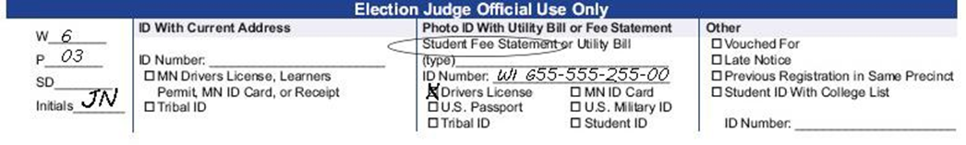
Figure 8: EJ Official Use Section with Answers to EDR Exercise Question 6
- D
- No, because the mortgage statement was dated September 30, which is more than 30 days before the election. His other options include a different bill at his address that is dated within 30 days of the election, or to update his driver’s license and provide the yellow receipt.
- D

Summary Statement Exercise Answers
- Number of ballots counted: 11
- Number of voter receipts or signatures on all rosters: 9 (pre-registered roster) + 3 (election day registration roster) = 12.
- The numbers do not match. Upon inspection of the Incident Log, you notice that Danny Smith signed the roster and then afterward was informed he is in the wrong polling place. Danny did not receive a ballot. His signature should have been stricken with a note and the judge’s initials.
- Number of ballots counted: 11
- Number of voter receipts or signatures on all rosters: 11
- Additional statistics:
- Number of new registrants on election day: 3
- Ballot count adjustments from incident log: -2
- Number of signatures on roster: 11
- Number of unused ballots: 7
- Boxes A-E A: 18
- B: 7
- C: 11
- D: 18
- E: 0

Security Practices Quiz Answers
- B
- A
- D
- B (no)

General Knowledge Quiz Answers
- B
- A & B
- E
- B
- Curbside voting is when a voter is unable to enter the polling place and requests that you bring a ballot out to their vehicle.
- C
- D
- A
- B (False)
- D
- C
- C
- A
- B

Roster Quiz Answers
- D
- A roster notation is a word or abbreviation on the line in the polling place roster where voters sign their name. It indicates doubt regarding their eligibility to vote. An example is ‘Challenged—Voted Out of Precinct’
- A
- B
- C
- Tips for finding names in the roster include
  - Check spelling variations.
  - See if the first and last names were switched.
  - Check multiple combinations for two-word and hyphenated names.
  - See if an apostrophe was omitted.
- D

Registration Judge Quiz Answers
- A
- B
- B
- C
- C
- C
- B
- C
- B
- D
- C

Demonstration & Ballot Judge Quiz Answers
- A (True)
- C
- E
- B
- C
- D
- Two judges must initial each ballot before it can be given to a voter.

Ballot Counter Judge Quiz Answers
- C
- A
- B
- C
- B
- C

Voter Challenges Quiz Answers
- C
- B (False)
- A (True)
- B
- A
- A

Polling Place Conduct Quiz
- C
- A
- C
- C
- C
- C
- D

Minnesota Election Judge Guide Workbook
Elections Division – Office of the Minnesota Secretary of State
Updated 4/28/2022

