Minnesota Employee Email (recommended for National Voter Registration Day, Sept. 27)
Customize these templates for employees or members residing in Minnesota.

SUBJECT LINE: It’s Election Year—Are You Registered to Vote?
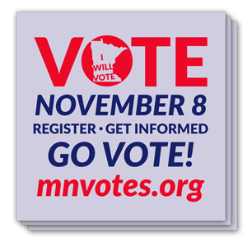
Today is National Voter Registration Day, which means it’s the perfect time to learn more about what you will see on your ballot when you vote in just a few weeks. This year, voters will elect their U.S. House representatives, all state representatives and senators, many local and county officials, vote on a state constitutional amendment — and elect the next U.S. president.
If you’re eligible, I encourage you to exercise your right to vote. I also encourage you to be informed about the issues and candidates. Visit the Office of the Minnesota Secretary of State at mnvotes.org to:
- Register to vote or check the status of your registration.
- Request an absentee ballot to vote early by mail — or in person at your elections office. To learn more about voting by absentee ballot, watch Vote Early, Vote Absentee!
- View your sample ballot.
Here are two key dates to remember:
- October 18 — Deadline to register in advance of Election Day and save time at your polling place.

- November 8, Election Day — Voters can register on Election Day at their polling place. Most polling places are open 7 a.m. to 8 p.m.
Thank you for participating in our democracy and voting on Election Day.

[NAME, TITLE]

