Temporarily Out-of-State Employee Email (recommended for September 1)
Customize these templates for employees or members who are Minnesota residents temporarily out-of-state.

SUBJECT LINE: Out-of-State Is No Excuse—Request Your Absentee Ballot
With a just over two months until Election Day, it’s the perfect time to learn more about what Minnesotans will see on their ballots when they vote this fall. This year, voters will elect their U.S. House representatives, all state representatives and senators, many local and county officials, vote on a state constitutional amendment — and elect the next U.S. president.
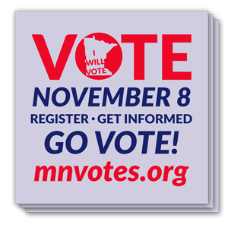
Since you’re currently outside of Minnesota, I encourage you to request an absentee ballot today — it only takes a few minutes. To learn more about voting absentee, watch Vote Early, Vote Absentee!
If you have absentee voting- or election-related questions, visit the Office of the Minnesota Secretary of State at mnvotes.org where you can check or update your registration, view your sample ballot, and more.
You may request an absentee ballot at any time. A ballot with instructions will be sent to you after they become available on September 23. Complete your ballot and forms as soon as possible and return by mail. Your ballot must be received by Election Day in order to be counted.

Thank you for participating in our democracy and voting on Election Day.

[NAME, TITLE]

