Out-of-Country Employee Email (recommended for August 1)
Customize these templates for employees or members who are Minnesota residents outside the United States.

SUBJECT LINE: Outside the U.S. Is No Excuse—Request Your Absentee Ballot
With just over two months until Election Day, it’s the perfect time to learn more about what you will see on your ballot when you vote this fall. This year, voters will elect their U.S. House representatives, all state representatives and senators, many local and county officials, vote on a state constitutional amendment — and elect the next U.S. president.
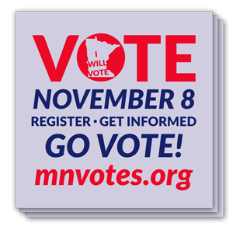
Since you’re currently outside of the country, I encourage you to request an absentee ballot online today — it only takes a few minutes. Voters abroad can use a special voting process different from absentee voters statewide. To learn more about voting from abroad, click here.
When you apply, you will choose to have voting materials sent by email, mail or fax. The Office of the Minnesota Secretary of State recommends you apply for your absentee ballot by September 1; ballots are sent starting September 23.

Thank you for participating in our democracy and voting on Election Day.

[NAME, TITLE]

