Minnesota Employee Email (recommended for November 1)

SUBJECT LINE: One Week to Election Day!
I encourage you to cast your ballot on Election Day, next Tuesday, November 8.
- You may still vote early in person at your elections office now through Monday, November 7.
- Find your polling place. Most polling places are open 7 a.m. to 8 p.m.
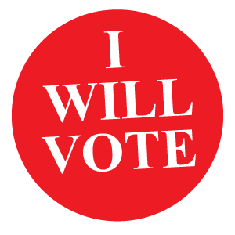
- If you need to register or update your registration to your current address, you may do so at your polling place.
All Minnesota voters have the right to take paid time off to vote and are not required to use personal leave or vacation time. Please inform your supervisor if your schedule will change due to voting.

Thank you.

[NAME, TITLE]

