Out-of-Country Employee Email (recommended for October 1)

SUBJECT LINE: Vote from Abroad with Your Absentee Ballot
If you haven’t yet returned your absentee ballot, please do so today! The Office of the Minnesota Secretary of State recommends you mail your ballot back before October 8. Election officials must receive your ballot by November 8 or it will not be counted.

Return you materials early enough to account for delivery time via mail, package delivery service (such as FedEx or UPS) or the diplomatic pouch at a U.S. embassy or consulate. You cannot return your ballot by email or fax. If you have already returned your absentee ballot, you can track your ballot.

Unfortunately, in 2012, 15 percent of Minnesota voters outside the U.S. who requested an absentee ballot did not return their ballot. Don’t let that be you — please return your ballot today!
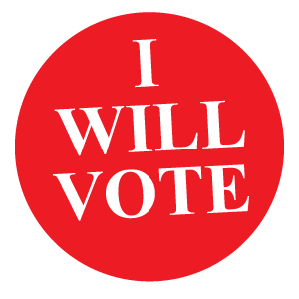
If you have not received voting materials in time, download and print an emergency ballot called the Federal Write-In Absentee Ballot, or FWAB. The ballot will have blanks for you to write your choices. Your write-in ballot must be returned by Election Day.

Thank you.

[NAME, TITLE]

