2016

ELECTION JUDGE WORKBOOK

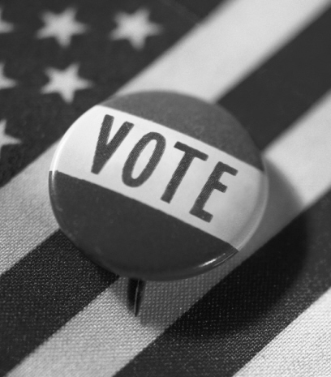

Office of the Minnesota Secretary of State
180 State Office Building
100 Rev. Dr. Martin Luther King Jr. Blvd.
St. Paul, MN 55155
Phone: (651) 215-1440
Toll Free: 1-877-600-8683
Minnesota Relay Service: 1-800-627-3529
Email: elections.dept@state.mn.us
Website: www.sos.state.mn.us

Table of Contents
Precinct Finder Exercise 3
Election Day Registration Exercise 4
Summary Statement Exercise 8
Summary Statement Materials 9
Summary Statement to Complete 10
General Knowledge Quiz 11
Answer Key 20

Precinct Finder Exercise
Use this sample precinct finder to answer the questions below

- The precinct finder should be used to verify the address of (circle all that apply):
- Every voter who registers to vote on Election Day.
- Every voter who is not sure if they are in the correct polling place.
- Every voter.
- Every voter that has a challenge.
- Sam goes to Shoreview P-6. His address is 604 Schifsky Rd. Is this the correct polling place? If not, where is Sam’s correct polling place?
- At St. Paul W-3 P-3, Kerry would like to register and vote. Her address is 900 Scheffer Ave. Is Kerry in the correct precinct? If not, where is her correct precinct?
- Sam lives at 3640 Scheuneman Rd and goes to vote at Gem Lake P-1. Is this correct? If not, where is his correct precinct?

Election Day Registration Exercise
- Victor presents a photo ID and a current bank statement. However, he does not have a paper copy of the bank statement, just an electronic one on his smartphone. Can Victor register?
  - No, the voter must a provide a paper copy to attach to the registration application.
  - It depends on whether the smartphone is made by Apple or Samsung.
  - Yes, the bill can be displayed on any electronic device.
- Susie’s Minnesota driver’s license has her old address. She does not receive any bills in her name. What are Susie’s options? Circle all that apply.
- A roommate can vouch for her, as long as her roommate is already registered or registers on Election Day with any method except vouching.
- She can update her driver’s license and bring in her yellow receipt for the new license.
- She can use the “welcome to the city” letter she received from her city government.
- She should go vote at the precinct that is correct for her old address.
- Sarah lives in a house with 9 college roommates. All need to register. The lease and house utility bills are in Sarah’s name. What options do her roommates have? Circle all that apply.
- Sarah registers and then vouches for 8 of her roommate. One roommate needs to use another form of Election Day proof of residence.
- Sarah’s roommates can provide another bill, such as cell phone or bank statement, with their current address, along with a photo ID.
- They cannot register. College students have to vote in their home precincts (where their parents live).
- Sarah registers and then vouches for all of her roommates.
- Josh moved to the apartment directly across the hall from his old apartment. He is already on the registered roster showing his old apartment. What documentation does Josh need in order to register to vote? (circle the best answer)
- A utility bill that lists his apartment as 5A.
- Another resident in her building (or precinct) that could vouch for him.
- Nothing as “previous registration in the precinct” is sufficient.
- He could update his driver’s license to reflect his apartment change.
- Jane Quincy would like to register to vote at the address of 3300 Century Ave N, White Bear Lake, MN 55110 with the following documents for an election on November 8, 2016. Can she register with the following documents?
  - Yes
  - No
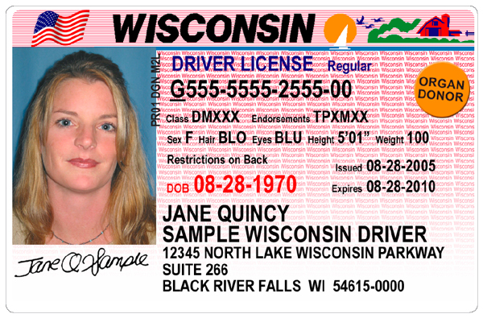

October 10, 2016
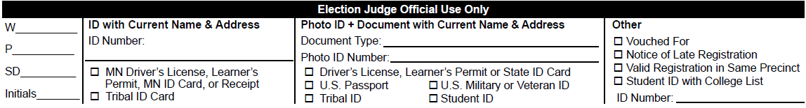
- If Jane presented you with these documents, show how would you complete the “Election Judge Official Use Only” section at the bottom of the application:

- Kristin moved to Minnesota 31 days prior to Election Day, but only has the yellow receipt that was given to her at the DMV when she applied for a Minnesota license. She wants to know what else she needs to register, since the yellow receipt does not have her photo on it. What advice can you give as a registration judge?
- Kristin can vote a provisional ballot, which will be accepted once her driver’s license arrives in the mail.
- Kristin needs to bring a current utility bill with her to confirm her residency.
- Kristin is still eligible to vote in her prior state of residence, and should have voted absentee from there.
- Kristin can register using the yellow receipt alone.

- Can Gayle register for an election on November 8, 2016 at her current address (345 7th St W., St Paul, MN 55104) with the following documents? If not, list some of the documents she could use to register.

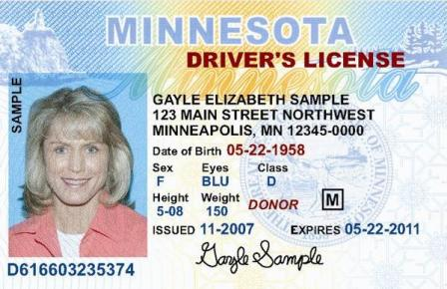
September 30, 2016

- Jeff hands you the following document. What else will he need in order to register?
  - A valid photo ID.
  - A valid photo ID and a current bill.
  - An old photo and a current bill.
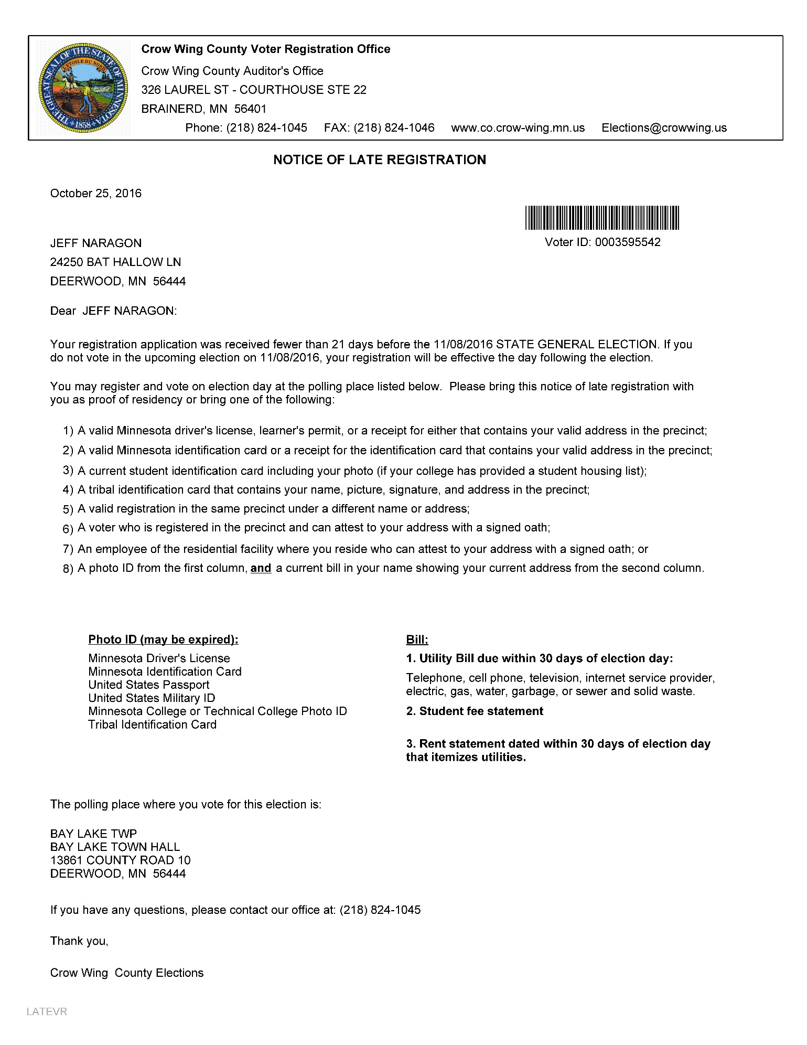
  - He does not need anything additional to register.

Summary Statement Exercise
Practice compiling basic election night statistics using the instructions below and the supplemental documents on page 9. List your answers on the sample summary statement on page 10.
Instructions for Completing the Summary Statement
The first step in gathering statistics is to make sure that the number of ballots the machine counted matches the number of people who voted. The results tape (see page 9) will list the number of ballots counted — compare that to the number of signatures on both voter rosters (also on page 9). Do not count lines marked ‘AB’ as signatures.
- Number of ballots counted: _________________
- Number of voter receipts or signatures on all rosters: _________________
- If the numbers do not match, examine the incident log and provide an explanation of what happened:

Now, provide a new tally of ballots counted and voted receipts to ensure they match:
- Number of ballots counted: _________________
- Number of voter receipts or signatures on all rosters: _________________
Finally, document the remaining statistics onto the Summary Statement on page 10.
- Number of new registrants on Election Day.
Count voter signatures on the Election Day Registration Roster, or count registration applications.
- Ballot count adjustments (+/-)
These reflect actual counts made by Ballot Judges after opening a packet; the discrepancies are recorded in Incident Log.
- Number of signatures on roster
Add together the number of signatures on the Pre-Registration and Election Day Registration Rosters or count voter receipts. Do not count ‘AB’ notations printed, written, or stamped on the registered roster. This must match the number of ballots counted on the results tape.
- Number of unused ballots
Count the number of ballots still in packets, plus ballots from opened packets that went unused
- Add the totals in boxes A-E

Summary Statement Materials
Results Tape

Pre-Registered Roster

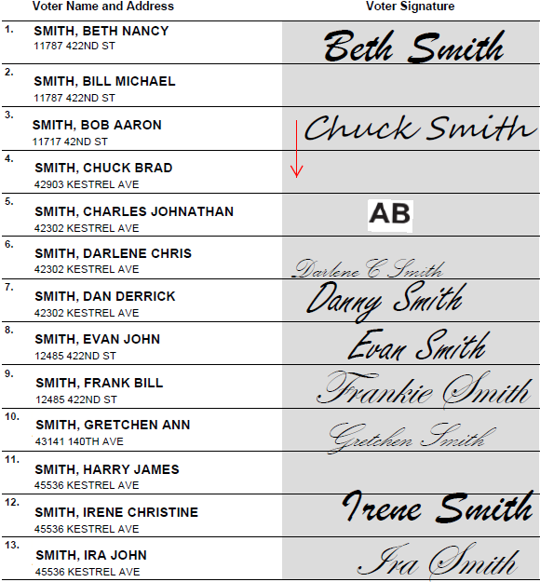
**Voting Results Report***
20:10:34 11/08/16
State General Election
Date: November 8, 2016
Northfield W-1 P-3
Total Ballots 11
-------------------------------------
Races
President
#Running 4
# To Vote For 1
-------------------------------------
Aaron Apple 2
Beth Banana 4
Carl Car 1
Denise Dog 3
Under Votes 1
Write-In 0
-------------------------------------
Total Votes 11

Election Day Registration Roster

Incident Log

- 9:50 AM Chuck Smith signed the incorrect line on page 1 of the registered roster. Red arrow indicates correct line.
- 10:45 AM: Opened ballot pack with two less ballots than indicated. (-2)
- 3:00 PM Danny Smith signed the roster, then mentioned to the head judge that he had moved recently. He was directed to his new polling place, and did not vote a ballot.

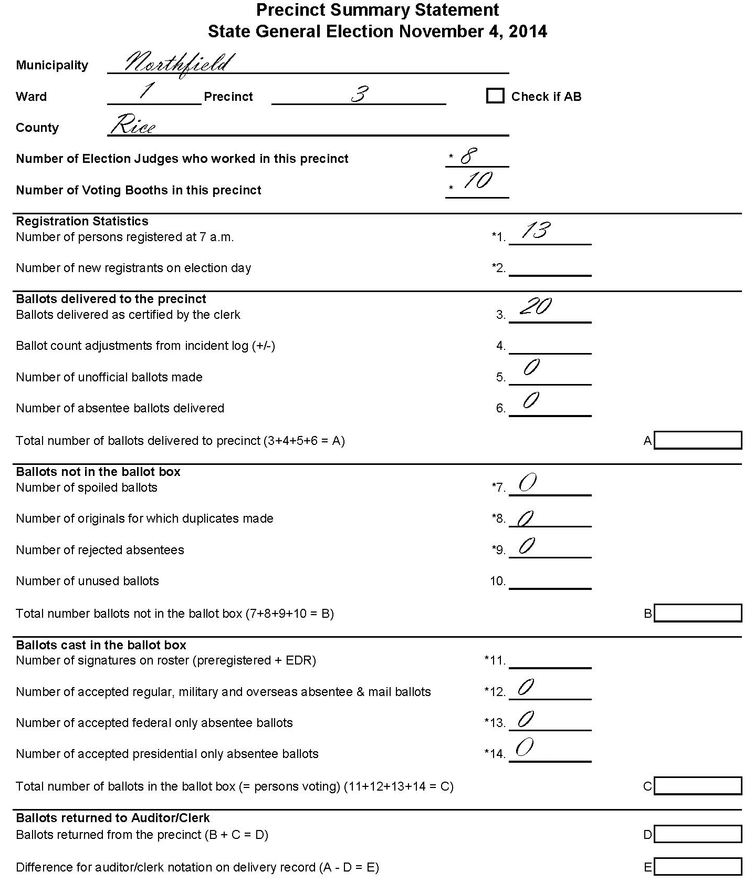
Summary Statement to Complete
Precinct Summary Statement
State General Election November 8, 2016

General Knowledge Quiz
- Who issues ballots to the voters?
- The Registration Judge.
- The Judge who receives voter receipts.
- The Ballot Counter Judge.
- The Head Judge.
- What events must be noted in the Incident Log when they occur? Circle all that apply.
- Discrepancies in ballot counts when opening ballot packets.
- Unusual events or incidents.
- The names of vouchers.
- The names of people who accompany voters as assistants.
- What is a voter receipt?
- The receipt a voter gets when they register.
- The receipt a voter gets after they vote.
- The receipt a voter gets if they use curbside voting.
- The receipt a voter gets after signing the pre-registered or election day registration roster.
- What is the minimum number of election judges in a polling place who must represent different major political parties?
- 4
- 2
- There is no minimum.
- What is curbside voting?

- Who can mark their ballot using the ballot marking machine? Circle the best answer.
- Voters who are blind.
- Voters with any form of disability.
- Any voter.
- You are setting up the ballot marking machine—what factors do you use to decide where to place it?
- Proximity to electrical outlet.
- Privacy afforded to the voter.
- Obstacles in the path of voters approaching it.
- All of the above.
- Which of the following are required by law to be in every polling place?
- Chairs for voters who need to sit on while waiting to register or vote.
- A ballot counter machine.
- A list posted on the wall of emergency phone numbers.
- True or False (circle answer): Political discussions between judges are okay if not within earshot of voters.
- If there is a line of voters waiting to vote at 8:00 pm, the election judges should:
- Stop issuing ballots immediately.
- Determine who the last person in line is at 8:00 p.m.
- Announce that the polling place is closed at 8:00 p.m. & all in line are allowed to vote.
- Both b and c.
- What should be in the ballot box at 7:00 a.m.?
- Blank ballots.
- Election supplies.
- Nothing.
- How close can a voter come to the ballot box if they are not about to cast a ballot?
- There is no rule.
- They must stay at least 15 feet away.
- They must stay at least 6 feet away.
- What is a summary statement?
- A document completed at the end of the day of the precinct’s voting, registration and ballot statistics.
- A document that lists any problems or unusual events during the day.
- The document an authorized challenger presents when making a challenge.
- A document provided at the beginning of the day summarizing how many ballots were delivered.
- A voter asks you what effect a ballot question will have if it passes. What should you say?
- Provide basic information about the ballot question’s effects, as long as it is fair and impartial.
- Tell the voter you cannot provide any information.
- Give your opinion, but clearly state that it is opinion and there is another side to your view.
Roster Quiz
- A voter signs the roster, and then mentions they have recently married and changed their name. What should you do?
- Make the voter sign their new name on the roster.
- Arrest the voter for impersonation.
- Ask the voter to update their registration sometime in the coming weeks.
- Direct the voter to the registration table to update their registration.
- What is a roster notation? Give an example.

- A voter comes to sign the roster and the notation ‘Challenge—Postal Return’ is next to their name. When administering the roster challenge process, what question is most appropriate?
- What is your current address?
- What country were you born in?
- What is your full legal name?
- A voter sees that someone else has already signed next to their name. Upon inspection, you find that the voter directly above signed on the wrong line. How will you handle this situation?
- Call the voter who signed the wrong line and ask them to come back to the polls.
- Ask your head judge for guidance.
- Tell the voter that unfortunately, they cannot vote.
- What does “A.B.” mean on the signature line in the roster?
- They are the initials of the election judge who approved the roster.
- The voter has applied for an absentee ballot, but it wasn’t received or returned.
- That the person voted by absentee ballot and cannot vote at the polling place.
- Name two tips for finding names in the roster:

- Under what circumstances must a voter who appears on the roster re-register? Circle all that apply.
- Change of name.
- Change of address in the precinct.
- A voter’s name is misspelled due to a clerical error.
- All of the above.
Registration Judge Quiz
- What is one of the first steps when registering a voter?
  - Confirm that the voter is at the correct precinct, using the precinct finder.
  - Give the voter a copy of the Minnesota voter’s bill of rights.
  - Ask the voter to show their photo ID.
- Mickey moved from St. Paul to Bemidji five days before the election. Can he vote in Bemidji?
  - No, because he hasn’t resided in the precinct for more than 20 days.
  - Yes. A voter must live in Minnesota for 20 days, not in a specific precinct for 20 days.
  - No, he must vote from his previous address.
- Paige forgot her ID. Can she leave and come back with it later?
  - No. If someone leaves without voting, they cannot return later to vote.
  - Yes. Voters can leave and come back anytime during voting hours to register and vote.
- Can a voter who registers on Election Day vouch for another voter? Circle the best answer.
  - No, only pre-registered voters can vouch for others. Their name must be on the roster.
  - Yes, people who register on Election Day can vouch for others.
  - Yes, as long as the voter did not also register by being vouched for.
- A residential facility staff person wants to vouch for 12 residents. Can she?
  - No. She can only vouch for up to 8 of the residents.
  - No. Staff people cannot vouch for residents, only another registered voter can vouch for them.
  - Yes, she can vouch for all 12—unlike a registered voter who can vouch for a maximum of 8, residential facility staff can vouch for any eligible voters who reside at the facility.
- Who cannot be a voucher?
- A candidate at the election.
- An election judge who is a registered voter in the precinct.
- A person who registers the same day with a voucher.
- A voter comes to register who has had a felony conviction. What should you tell him?
- He cannot vote.
- He can vote if he has completed all the terms of his sentence, including probation and parole.
- He can vote after petitioning the state to restore his voting rights.
- He can vote after presenting a document from the Department of Corrections saying he is eligible.
- Which of the following is not a requirement to vote?
- Be a citizen of the United States.
- Be at least 18 years of age.
- Be a resident of the precinct for at least 20 days.
- Not be serving a felony sentence.
- Which of the following documents may not be used as proof of residence?
- Current electric bill and a US passport.
- Property tax statement.
- Receipt for a Minnesota learner’s permit.
- Oath of a registered voter from the same precinct.
- A woman who is under guardianship comes to vote, but her guardian is not present. Can she vote?
- Yes, as long as she signs a statement saying her guardian was unable to come.
- No, she cannot sign the roster herself, it must be signed together with her guardian.
- No, voters under guardianship or who have given power of attorney to someone can no longer vote.
- Yes, a person under guardianship can vote as long as a court order did not specifically revoke their voting rights.
- A voter tries to register who has a heavy accent and doesn’t speak English very well. You suspect they might not be a U.S. Citizen. What should you do?
- Ask the voter to show their naturalization papers.
- Make a challenge to the voter’s eligibility, and have another judge ask questions about their eligibility to vote.
- If the voter provides the necessary documentation, you must register the voter. Election judges cannot request additional documents or challenge a voter based on suspicion.

Demonstration & Ballot Judge Quiz
- True or False (circle answer): A voter can only vote for candidates from one political party in a Primary Election.
- A voter asks how a particular ballot question was placed on the ballot. How should you respond?
- If you know, explain the process by which the question was placed on the ballot.
- If you don’t know, call your local election official to receive an explanation.
- You should avoid discussing candidates or ballot questions altogether with voters. Explain that you cannot discuss this voters, and direct them to the instructions on the ballot for how to complete that portion of the ballot.
- What should you use to demonstrate to the voter how to mark their ballot? Circle all that apply.
- An official ballot.
- The demonstration ovals printed on a voter receipt, if provided.
- A separate demonstration ballot provided by your jurisdiction.
- The voter’s ballot that they just received.
- After opening a sealed a pack of ballots, what should you do?
- Lock the ballots in the provided supply box.
- Count the ballots to make sure the packet had the indicated number of ballots. Record any discrepancies in the Incident Log.
- Provide the ballots to the Head Judge for inspection.
- A voter wants to vote on an unoccupied table, instead of in a privacy booth. What should you say? Circle the best answer.
- Explain to the voter she must wait for a voting booth to open.
- Invite the voter to use the ballot marking machine.
- Confirm that it is okay for the voter to use a place of their choosing to mark their ballot.
- When should you issue a ballot to a voter? Circle the best answer.
- After the voter signs the roster or completes their registration.
- After the voter gives you their name and address.
- After the voter presents you with a voter receipt.
- What must two judges do to each ballot before it can be given to a voter?

Ballot Counter Judge Quiz
- What should you do first when the ballot counter rejects a voter’s ballot?
- Immediately press the override button and reinsert the ballot.
- Scrutinize the ballot carefully and inform the voter of the reason for rejection.
- Explain the error message on the ballot counter to the voter.
- Place the ballot in the “auxiliary slot.”
- What is an overvote?
- Voting for more candidates than is allowed for that office.
- Making your mark over the oval, instead of within it.
- The marks made on the ballot when you flip it over to the back.
- What is an undervote?
- Making your mark under the oval, instead of within it.
- Voting for fewer candidates than is allowed for that office.
- What is a spoiled ballot?
- An absentee ballot that arrives after 8:00 p.m. on Election Day.
- The wrong ballot for the precinct.
- A state primary ballot containing votes for only nonpartisan candidates.
- A ballot that has been returned to the election judges in exchange for another blank ballot.
- The ballot counter has stopped working. What should you do?
- Have voters place their ballots in a polling place supply box, overseen by two judges of different parties.
- Have voters insert their ballot in the auxiliary compartment of the ballot counter.
- Collect the ballots by hand and organize them into groups of 25.
- Ask voters to wait while you call a local election official for instructions.
- How many feet away must others keep from the ballot counter?
- Far enough away to not see what a voter marked on their ballot.
- 3 feet from the voter immediately in front of them.
- 6 feet.
Voter Challenges Quiz
- Who cannot appoint a challenger?
- A political party.
- A nonpartisan candidate for office.
- A partisan candidate for office.
- True or False (circle answer): a challenger appointed by a political party can monitor all aspects of polling place management and operation.
- True or False (circle answer): a challenger is not allowed to speak directly to a voter.
- A challenger sees a voter trying to register who appears nervous and tense. The challenger wonders if the voter is not eligible to vote. Can the challenger file a challenge?
- Yes
- No
- It depends on if the voter can provide a proof of citizenship document.
- A challenger says a voter trying to register is still serving a felony sentence. After taking the oath and answering the election judge’s question, the voter states they are no longer serving a felony sentence. Is the voter allowed to vote?
- Yes, as long as the voter affirms the oath that they meet all eligibility requirements.
- No, if a voter is challenged, they cannot vote during the present election.
- The voter can vote after clearing their name and data with the Department of Corrections.
- The voter can vote, but must use a provisional ballot.
- Who can challenge a voter?
- An authorized challenger, election judge, or voter.
- Any candidate at the election.
- The municipal clerk.
Polling Place Conduct Quiz
- Which of the following buttons may be deemed ‘political’ and so should be covered or removed by a voter in the polling place?
  - “Don’t Tread on My Gun Rights”
  - “I’m Pro-Choice and I Vote”
  - “Vote Jim Naragon for U.S. Senate”
  - All of the above.
- Can an assistant physically mark a ballot for a voter?
- Yes, as long as you record their name in the Incident Log.
- No, a voter must mark their own ballot.
- Yes, as long as the assistant does not physically mark a ballot for more than 3 voters in an election.
- How many voters can an interpreter assist with registering to vote at the polling place?
  - 1
  - No more than 3 voters in an election.
  - An unlimited amount.
- A voter wants to file a complaint about the election—how will you accommodate their request?
- Ask the voter to call the Secretary of State’s Office.
- Have the voter call the Mayor.
- Provide the voter with a HAVA Complaint Form.
- Take the voter’s statement and note it in the Incident Log.
- Are news media permitted in the polling place?
- No
- Yes, when given prior written permission by local election officials.
- Yes, if they can show ID and credentials.
- Yes, but only between the hours of 10:00 a.m. and 2:00 p.m.
- What should the election judges do if they find a campaign sign posted at the entrance to the polling place?
- Call the police department.
- Call the news media.
- Remove the sign and call local election officials.
- Call the candidate to whom the sign belongs and ask them to remove it.
- Who may not assist a voter in marking a ballot?
- Two election judges of different parties.
- The voter’s spouse, child, parent or sibling.
- A student.
- A candidate at the election.

Answer Key

Precinct Finder
- A & B
- No. Sam’s polling place is Shoreview P-4
- No. Kerry’s precinct is St. Paul W-2 P-03
- Yes, that is Sam’s precinct.

Election Day Registration Exercise
- C
- A & B
- A & B
- C
- A
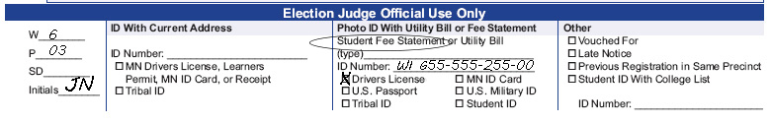
- D
- No, because the mortgage statement was dated September 30, which is more than 30 days before the election. Her other options include a different bill at her address that is dated within 30 days of the election, or to update her driver’s license and provide the yellow receipt.
- D

Summary Statement Exercise
- Number of ballots counted: 11
- Number of voter receipts or signatures on all rosters: 9 (pre-registered roster) + 3 (election day registration roster) = 12.
- The numbers do not match. Upon inspection of the Incident Log, you notice that Danny Smith signed the roster and then afterward was informed he is in the wrong polling place. Danny did not receive a ballot. His signature should have been stricken with a note and the judge’s initials.
- Number of ballots counted: 11
- Number of voter receipts or signatures on all rosters: 11
Additional statistics:
- Number of new registrants on election day: 3
- Ballot count adjustments from incident log: -2
- Number of signatures on roster: 11
- Number of unused ballots: 7
- Boxes A-E
A: 18
B: 7
C: 11
D: 18
E: 0

General Knowledge Quiz

- B
- A & B
- D
- B
- Curbside voting is when a voter is unable to enter the polling place and requests that you bring a ballot out to their vehicle.
- C
- D
- A
- False
- D
- C
- C
- A
- B

Roster Quiz
- D
- A roster notation is a word or abbreviation on the line in the polling place roster where voters sign their name. It indicates doubt regarding their eligibility to vote. An example is ‘Challenged—Voted Out of Precinct’
- A
- B
- C
- Tips for finding names in the roster include
- Check spelling variations.
- See if the first and last names were switched.
- Check multiple combinations for two-word and hyphenated names.
- See if an apostrophe was omitted.
- A & B

Registration Judge Quiz
- A
- B
- B
- C
- C
- C
- B
- C
- B
- D
- C

Demonstration and Ballot Judge Quiz
- True
- C
- B & C
- B
- C
- C
- Two judges must initial each ballot before it can be given to a voter.

Ballot Counter Judge Quiz
- C
- A
- B
- D
- B
- C

Voter Challenges Quiz
- C
- False
- True
- B
- A
- A

Polling Place Conduct Quiz
- D
- C
- C
- C
- C
- C
- D

